**PYTHON PROGRAMMING**

|  |  |
| --- | --- |
| Assignment Date | 23 September 2022 |
| Student Name | S.Bala subiramanian |
| Student Roll Number | 910619205014 |
| Maximum Marks | 2 Marks |

**1.Build a python code, Assume u get temperature and humidity values (generated with random function to a variable) and write a condition to continuously detect alarm in case of high temperature.**

**Solution:**

import random

def temperature():

value=random.randint(25,100)

return value

t=temperature()

t=int(input("Enter the temperature value"))

def humidity():

range=random.randint(40,100)

return range

h=humidity()

h=int(input("Enter the humidity value"))

if t>30:

print("High temperature detetcted")

print("Buzzer on,alarm sound is high")

elif t==30:

print("Temprature reached maximum thershold of 30 degrees celsius")

else:

print("Temperature is good")

#for Humidity

if h>65 :

print("High humidity detetcted")

print("Buzzer on,alarm sound is high")

elif t == 65:

print("Humidity reached maximum thershold of 65 percent")

else:

print("Humidity is good")

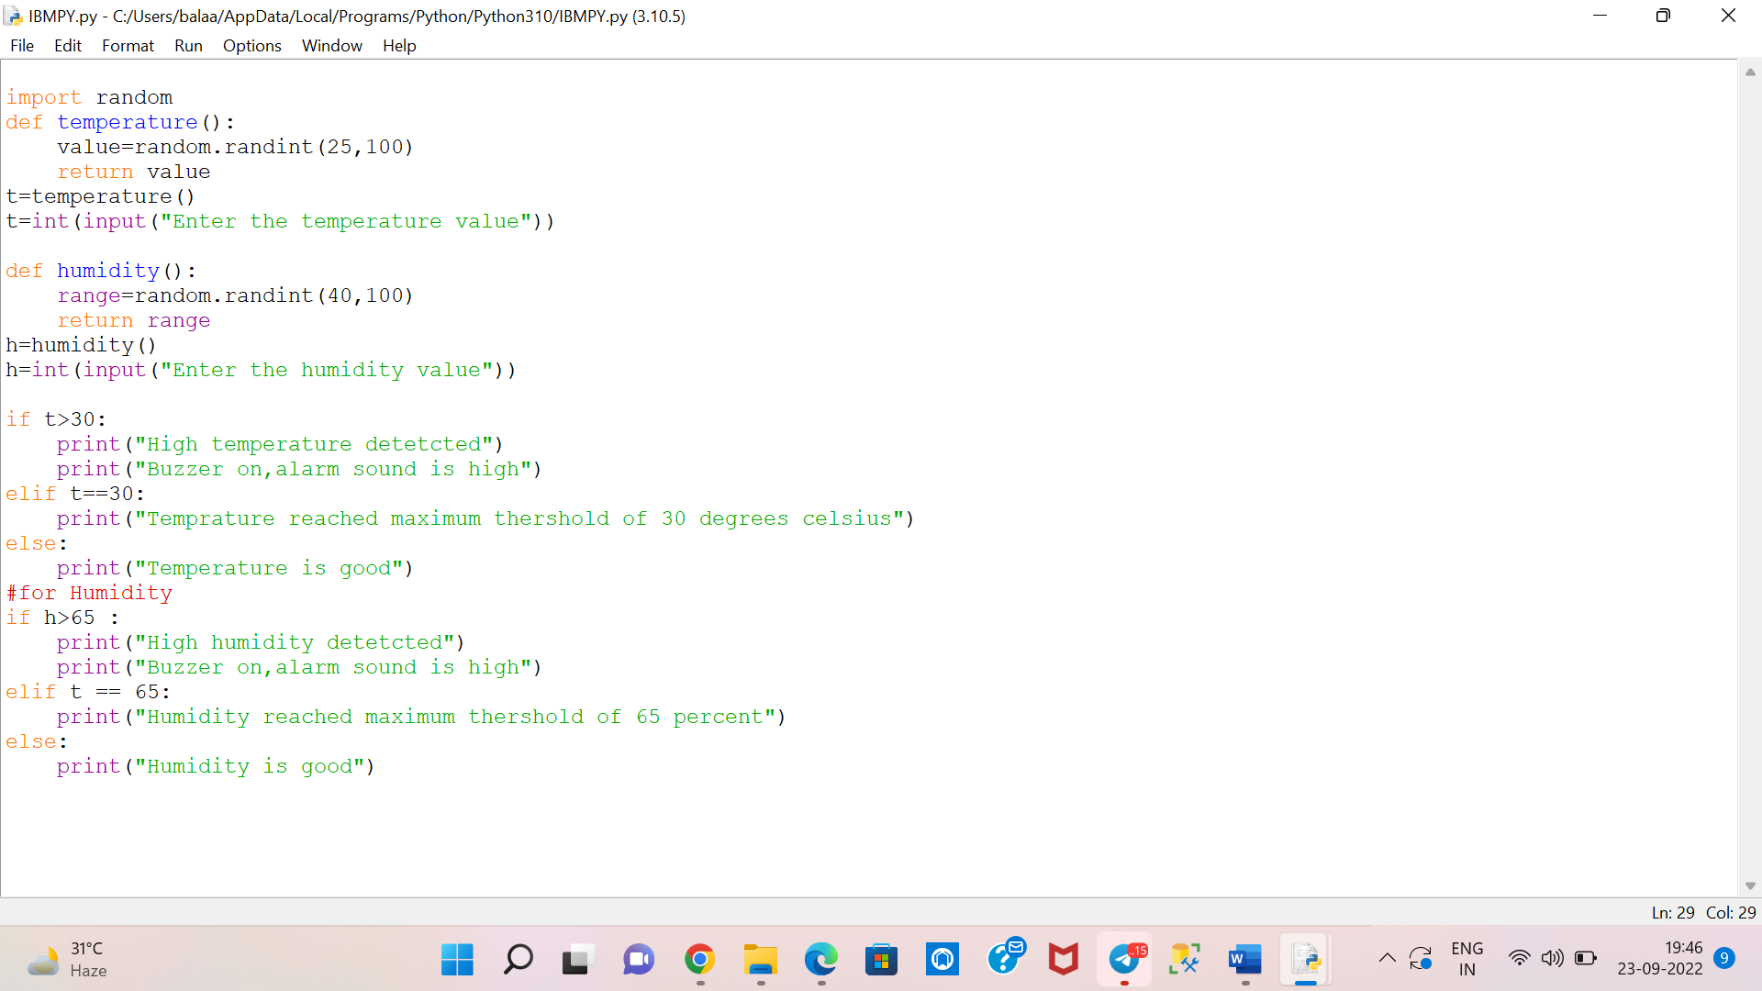

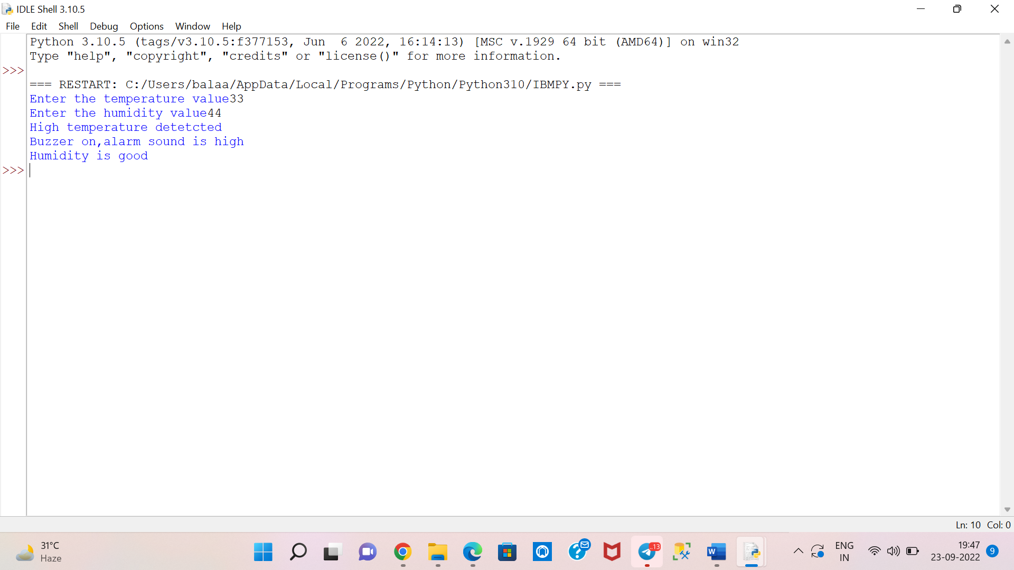Sample Input/Output: